

Great for Newcomers or LongTimers!

OA Central Ontario Intergroup Presents a:

***Quick* Step Study**

* SUNDAYS (Five sessions)

Nov 10, 17, 24, Dec 1 and 8, 2024

10:00am – 11:30am Eastern Time

(Toronto/New York time)

* By Zoom
* Free – Suggested donation $5 - $15
* Session Format: Write on the step, share on the step. (Read the step ahead of time.) Day 1 = Steps 1, 2, & 3, Day 2 is steps 3 – 4, etc.
* You don’t have to attend all the sessions.
* Registration: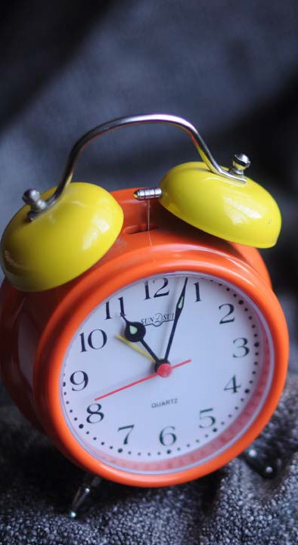
  + Registration required 24 hours ahead of the start date or individual session.
* Register by emailing:

coiquicksteps@oaontario.org

* CHECK YOUR JUNK MAIL if you don’t hear from us. Email again if that doesn’t work.



“This workshop has been all and more than I could have hoped for.”

~former workshop participant